Sweep Evaluation for Auto Link

Overview

Current processing
This is a new functionality.

New requirement
Configure Sweep Evaluation service for Auto Link where New HAL auction completes with functionality given below:
- Should make the call to Auto Link by Origin Code Trading property to determine if this Order can be sent to Sweep.
- If Sweep is not ON then,
- Trade and Book whatever meets CBOE price points.
- Otherwise process it regularly,
- Get the market for all Away Exchanges.
- Build grid of CBOE prices and Away Exchange prices.
  - The service will call the Auto Link Disqualify Exchange Trading property to eliminate the disqualified exchange.
  - The service will call the New Linkage Preferred Tie Exchange Trading property to give preference.
- Trade and Book whatever meets CBOE price points.
- Hand over the list/grid to be linked away.

Assumption
- All the required Trading Properties (AutoLinkOriginCodes, AutoLinkDisqualifyExchange, and NewLinkagePreferredTieExchange) are working.
- After Auction completes valid Auction Responses and other possible Trading has already been satisfied.
- The New HAL auction is implemented and flag is enabled.
- The origin code of Order is eligible to use New HAL auction.

For detail please refer to Requirement document.

Implementation
The new classes that will be implemented for this functionality are:
- SweepEvaluationServiceHomeImpl – This will be the new Home configured on Hybrid Trade Server to find the service for Sweeping.
- SweepEvaluationServiceImpl – This service is responsible for determine the eligibility, building the price list and their order preference for different Exchanges that needs to be Sweep.
- SweepElementImpl – The transient model object for each Exchange that needs be sweep and it will have attribute as Exchange name, Preference order, Price, Volume. This object implements the Comparable interface and therefore the compareTo method to be compared and sorted by Price and Preference order.

Main Flow
- As soon timer AuctionExpireTimerTask expires, it de-queues the task (incoming Order) and calls BrokerAuctionTimerCommand to acceptCommand.
- In turns it calls BrokerImpl that is responsible for going through right Broker Processor and eventually to Combo Queue to acquire Class level lock.
- After acquiring the lock call is delegated again to BrokerAuctionTimerCommand further that calls procesAuctionExpire on BrokerProcessorBase.
- After processing the Auction BrokerProcessorBase (or appropriate Processor) will invoke the processSweep(Book, AuctionResponses) method on SweepEvaluationService.
- The first thing SweepEvaluationService will do is to check if the Sweep is “ON” by calling AutoLinkOriginCodes Trading Property for that Origin Code.
- If it is “ON” then, will call the AutoLinkDisqualifiedExchanges to get all disqualified Exchanges to be eliminated from list.
- Also it will call the NewLinkagePreferredTieExchange Trading Property to get the Ording/Preference among the Exchanges in case if the two or more Exchanges Price ties.
- Then make a call to XTP to get the current market data for each Exchange.
- Create the Price Grid/list using the SweepElementImpl object for each Exchanges Price point and their preference order also put the CBOE Auction Response and any other possible tradable from the Book Depth into this list up to the total quantity equal to or less than incoming Order.
- Sort the list by Price and Preference Order (this will be always be 0 for CBOE Quotes, Orders, & Auction Response).
- Now take out all that is related to away Exchanges and put it in one bucket and CBOE related things in another bucket.
- Now loop through the CBOE related bucket/list and accumulate all tradable at same price point and send it for trading together.
- If any quantity is left in incoming Order then book it.
- Now send the list of away Exchanges to Linking service to be linked away.

Alternate Flow
If the Sweep is turned “OFF” follow the step 9, 10, 12, & 13 from main Flow.

Scripts
- None

Database
- None

SetContext

XML/DTD

Homes/Services
- SweepEvaluationServiceHome, SweepEvaluationServiceHomeImpl
- SweepEvaluationService, SweepEvaluationServiceImpl

ImplPlan
- Flow Diagram

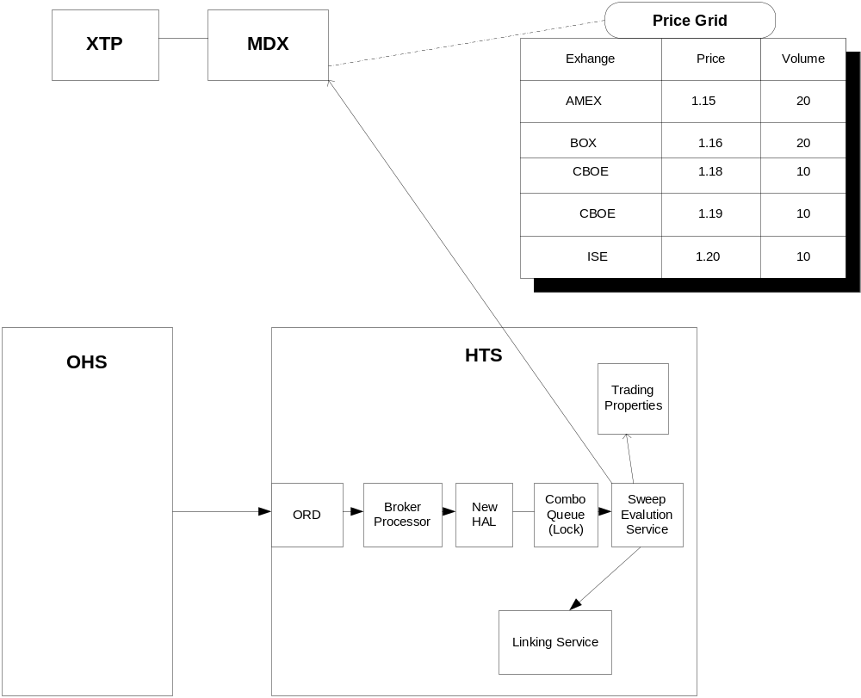

- Sequence Diagram
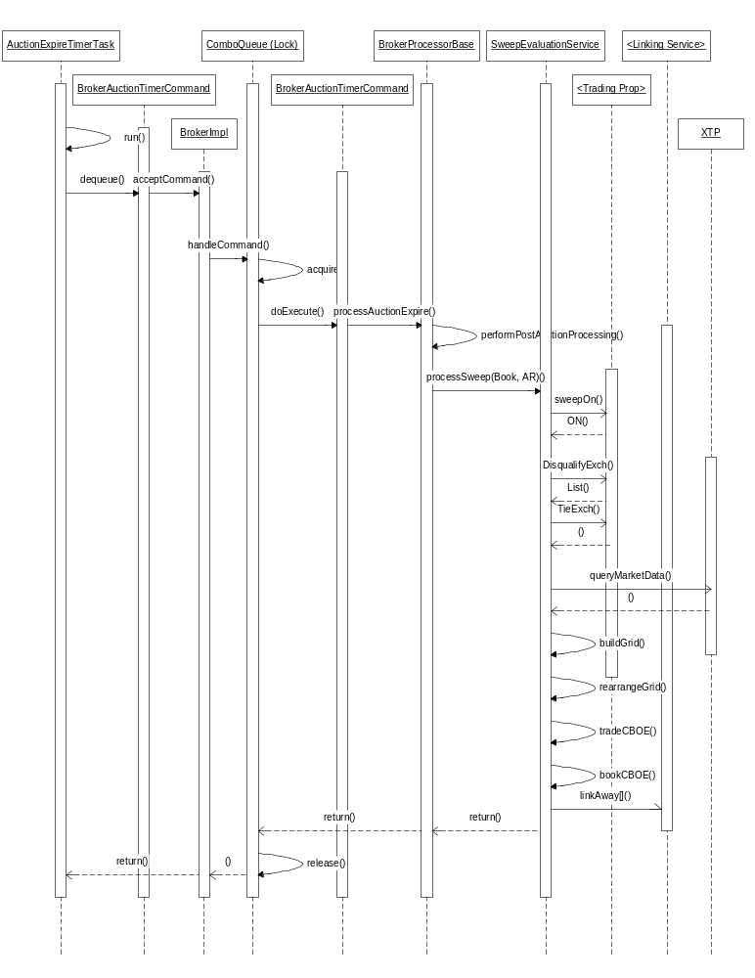

PerformanceTestingProcedure
- .

TestingProcedure

OperatorProcedure
- .

Fallback/Failover

